 | Knowledge - Children will learn | Children will be able to… | Prior Knowledge
Hurdles race | How to jump over hurdles correctly when running in a forward direction | Children will be able to jump over hurdles at speed with the correct technique  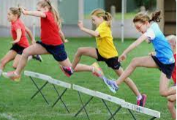  Hurdles will be approximately 40cm in height. Children to refine their hurdling from previous year using the following points:  - Demonstrate coordination and rhythm when hurdling  - Run at speed and fluency when jumping over hurdles  - Use preferred leg to complete the ‘lead’ over the hurdles | Understanding of lanes  Jumping  Balance  Running races
Relay race | How to correctly complete the relay race | Children will be able to hold the baton correctly whilst completing the changeover effectively.  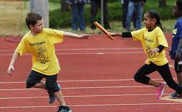  Children will learn how to:  - pass the relay baton effectively  - receive the relay baton effectively  - Use the down sweep technique correctly  - Work as a team to complete the race correctly and quickly | Running races  Understanding of lanes
3 legged race | How to complete the 3 legged race correctly and safely. | Children will be able to successfully complete the ‘3 legged race’ ready for Sports Day.  Children get into pairs of a similar height. The pairs must stand next to each other, tieing one of their legs to their partners to create 3 'legs' between the pair. On go, the pairs race to see who can end up at the ending point first.  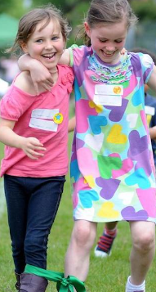  Key points to consider:  - Non-dominant legs are tied together  - Suitable space is given between pairs  - Partners should be of similar height  - Arm to go around partner’s waist  - Untied leg goes behind to start the race  - Keep legs in sync when moving forwards | Running races  Throwing  Understanding of lanes  Balance
Sack Race | How to hold onto the sack correctly whilst moving forward along the running track. | Children will learn the correct technique/ rules for the sack race.  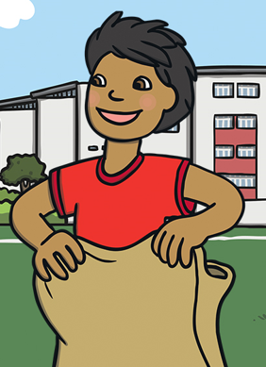  Children will look at the following points during the lesson:  - To jump in the sack to begin the race  - To jump from two feet to two feet  - Use arms and legs effectively to jump as far as possible  - Remain in the sack throughout the race | Jumping  Balance  Understanding of lanes
Space Hopper race | How to sit/ hold a space hopper and move along a track in a forward direction (80 metres) | 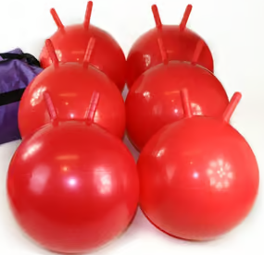  Children will be able to travel on a space hopper along the running track.  Children to be shown how to:  - Sit on the space hopper correctly.  - Hold on safely using the handles.  - move along the track quickly but safely.  - Focus ahead to ensure that they stay in the correct lane. | Running races  Understanding of lanes
Sprint race | How to move quickly along a track in a forward direction (80 metres) | Children will be able to travel quickly along the running track.  Key points during the lesson:  - Children to focus on staying in a straight line when sprinting along the running track.  - Focus on keeping their head up and looking at the finish line.  - Move arms and legs correctly to generate as much speed as possible. | Understanding of lanes  Running races
Javelin | How to hold a javelin correctly and throw it in a given direction. | 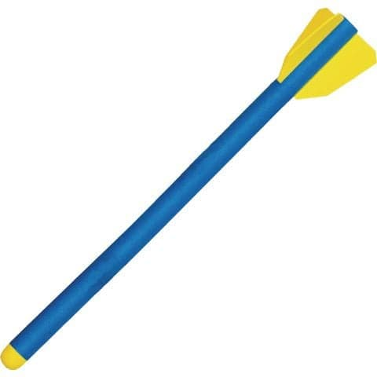  Children will be able to correctly throw a javelin using side stance.  Key points to go through:  - Grip the javelin by resting the javelin on the palm of your hand with the point aiming away from your body. If you straighten your arm the javelin should point towards you.  - Hold the javelin in the middle.  - Stand side on and aim with your free arm into the direction you want the javelin to go.  - Extend your arm and put your weight on your back foot.  - Transfer the weight to your front foot and release always keeping the javelin aimed forwards. | Throwing
Shot putt | How to correctly hold and throw a shot putt | Children will be able to use the correct technique to throw a shot putt.  - Stand side-on to the direction in which you intend to release the shot. If you are right-handed, this should be to your left; if you are left-handed, this should be to your right.  - The shot should remain pressed to the side of your neck until you are ready to release it, with the elbow of your throwing arm bent back on itself. Hold your non-throwing arm away from your body for balance.  - Practise twisting your hips and rotating your body, with the shot pressed firmly against your neck.  - You should be facing in the throwing direction when you release the shot.  - Try to release the shot at no more than 40 degrees from the ground for optimum distance. You do not want the shot to loop too high or drop too soon.  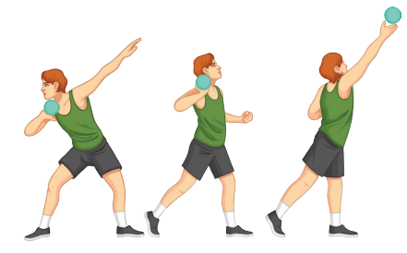  - For more power, bend at the hips and spring up as your release the shot. | Throwing
Discuss | How to correctly stand, hold and throw a discuss | Children will be able to use the correct technique to throw a discuss.  - The discus to be held flat against the palm; the edge of the discus sits on the pads of the first joints of the fingers; the thumb rests on the back of the discus.  - A balanced stance with the discus held up in front of the eyes; throwing hand on top of the discus; non-throwing hand underneath for support.  - Keeping the discus flat and the throwing hand on top while swinging the discus back off the supporting hand in a wide arc.  - The feet, hips, chest and shoulders to swing to the front on delivery as the weight shifts from back to front foot.  - From a "tall" delivery position, the delivery arm follows a wide slinging motion, with the discus being released off the index finger (out of the front of the hand) in a flat spin.  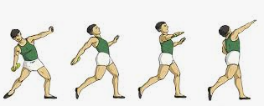 | Throwing

Keywords
running | sprint | 1st | rope | hurdles | javelin | space hopper
races | speed | 2nd | pull | high | throw | control
sports day | baton | 3rd | force | low | technique | bounce
lanes | relay | 4th | finish line | height | aim | grip
athletics | team | bronze | straight | jump | target | shot put
distance | position | silver | 3 legged | lead leg | direction | release
metres | focus | gold | sync | balance | lane | power

