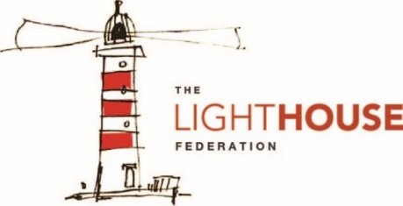
In Mathematics, your child will solve problems involving…
- Negative numbers
- Converting units
- Volume
In Reading, your child will explore a range of fiction and non-fictions texts. Focusing on:
- Inference and deduction.
- Summarising a text.
- Vocabulary and Author’s use of language.

In Writing, your child will study the text ‘Fritz and Kurt’ and will write
- Non-chronological report
- Informal letter
- Adventure narratives
In History, your child will…

- Explore different inventions and machines throughout the years.
- Explore Ironbridge 1779 (Local study)
- Explore Black Country museum 1978 (Local study)

In Religious Education (RE), your child will learn about…
- Religions in the local community
- What will make our town a more respectable place?

In Art and Design, your child will…
- Sketch and label a famous invention from the past.
In Design Technology (DT), your child will…
- Plan, create and evaluate using clay models.
In Computing, your child will…
- Coding
- Word processing
- Basic computing skills
In Science, your child will…
- Explain what gravity is.
- Identify different examples of air resistance.
- Plan an experiment to test air resistance.
- Name different types of gears and make a transmission.
In Geography, your child will…
- Explore towns and Cities that use a range of historical inventions and machines.
- Explore how to protect the Earth.
To enrich their curriculum experience, your child will…
- Exploring local studies of inventions and machines.
In Music, your child will…
- Composition
- Performing music
In Physical Education (PE), your child will learn about…
- Athletics
- Striking and fielding
In Personal, Social, Health, Education (PSHE), your child will…
- Learn about ‘Relationships’.

In Modern Foreign Language (French), your child will…
- Learn and explore French vocabulary for ‘Seasons’
- Have conversations in French about the different seasons.

