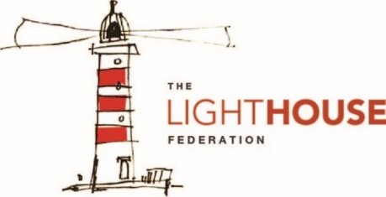
In Mathematics, your child will solve problems involving…
- Statistics
- -Shapes
- Position and Direction
- Decimals
In Reading, your child will explore a range of fiction and non-fictions texts. Focusing on:
- Inference and deduction.
- Summarising a text.
- Vocabulary and Author’s use of language.

In Writing, your child will study the text ‘Beowulf’ and will write
- Non-chronological report
- Persuasive letter
- Adventure narratives
In History, your child will…

- Explore the lives of Vikings.
- Create a time line of events pre and post Vikings.
In Religious Education (RE), your child will learn about…
- Religions in the local community
- What will make our town a more respectable place?

In Art and Design, your child will…
- Sketch photographs of different sections of a Viking boat.
- Be able to explain who Colin Archer is
In Design Technology (DT), your child will…
- Plan, create and evaluate a Vikings long boat.
In Computing, your child will…
- Begin to use and understand different databases.
In Science, your child will…
- Explain the process of evaporation
- Identify different properties of materials.
- Give reasons for the particular uses of everyday materials in relation to their properties.
In Geography, your child will…
- Explore towns and Cities within the Viking times.
- Know which countries Vikings came from and how they came to Britain.
To enrich their curriculum experience, your child will…
Explore a range of significant people related the Viking curriculum.
Edward the Confessor 1042 – 1066
Leif Erikson
Colin Archer
In Music, your child will…
- Explore music from India
- Perform compositions
- Songs for performance
In Physical Education (PE), your child will learn about…
- Target
In Personal, Social, Health, Education (PSHE), your child will…
- Learn about ‘Healthy me’.
- Explore short and long term personal goals.

In Modern Foreign Language (French), your child will…
- Learn and explore French vocabulary for ‘A school trip’
- Have conversations in French about schools trips.

