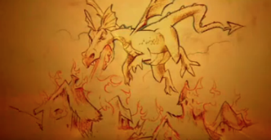
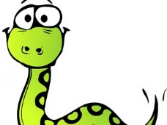
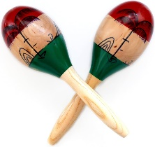
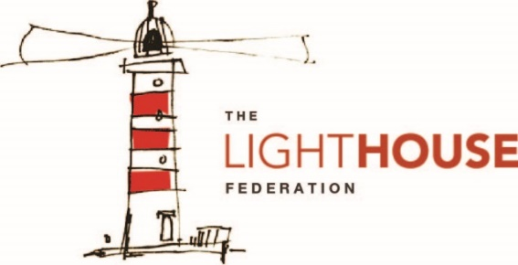
In Reading, your child will be…
- reading a range of fiction texts
- reading a range of non-fiction texts
following our Vipers structure.
In Writing, your child will be writing…
- a setting description
- a character description
- a narrative dilemma.
In Mathematics, your child will be…
- measuring mass and capacity
- completing calculations within the four operations including fractions
- interpreting data within bar charts and tables.

In Modern Foreign Language (French), your child will be…
- learning how to name parts of the body, clothing and months of the year.
In Physical Education (PE), your child will be…
- practising football and hockey skills.
In Religious Education (RE), your child will be…
- exploring why some people think Jesus is an inspirational person.
To enrich their curriculum experience, your child will be…
- preparing art work to be displayed in our own art gallery showcase and at Walsall Art Gallery.
In Music, your child will be…
- learning how to use hand signs and notations.
- practising keeping
a beat.
In Art and Design, your child will be…
- To explore colouring pencils to colour a Mayan mask adding fine detail and understanding symmetry.

In Design Technology (DT), your child will be…
- To create a chocolate bar using a range of moulds and ingredients and to evaluate the taste of chocolate.
In Personal, Social, Health, Education (PSHE), your child will be…
- Learning about helping and being helped
- Looking after the environment

In Computing, your child will be…
- learning how to follow a branching database
- creating branching databases for data they have collected.
In Science, your child will be…
- understanding what plants need in order to grow
- learning about the benefits of plants
In Geography, your child will be…
- Learning about the cocoa farmers who grow the cocoa beans at a fair price.
In History, your child will be…
- Learning about Fairtrade and how workers receive a fair price and fair treatment for the goods that they produce.

