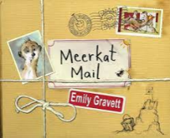

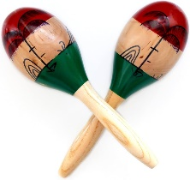
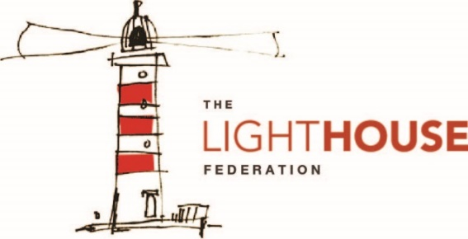
In Reading, your child will be…
- reading a range of fiction texts
- reading a range of non-fiction texts
following our Vipers structure.
In Writing, your child will be writing…
- a diary from a character’s point of view
- an informal letter to persuade
- a non-chronological report.
In Mathematics, your child will be…
- measuring length and perimeter
- adding and subtracting money
- drawing, recognising and making 2 and 3 dimensional shapes.
In Modern Foreign Language (French), your child will be…
- learning how to name parts of the body, clothing and months of the year.
In Physical Education (PE), your child will be…
- practising different movements, balances, rhythm and memory within dance.
In Religious Education (RE), your child will be…
- exploring why some people think Jesus is an inspirational person.
To enrich their curriculum experience, your child will be…
- preparing art work to be displayed in our own art gallery showcase and at Walsall Art Gallery.
In Music, your child will be…
- learning how to use hand signs and notations.
- practising keeping
a beat.
In Art and Design, your child will be…
- creating a sketch of different mythical creatures.
- Create different colours by mixing paint.
In Design Technology (DT), your child will be…
- Sewing leaf headdresses linked to the Ancient Greece era.
In Personal, Social, Health, Education (PSHE), your child will be…
Learning about keeping safe by managing decision making skills and staying safe online.

- Digital literacy
In Computing, your child will be…
- learning how to follow a branching database
- creating branching databases for data they have collected.
In Science, your child will be…
- exploring different types of forces and how magnets work. 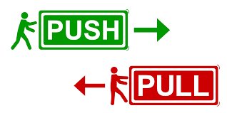
In Geography, your child will be…
- identifying the location of Europe and the location of Greece by using a map.

In History, your child will be…
- Focussing on Ancient Greece by understanding the historical context and explain the key significance of key historical events.

