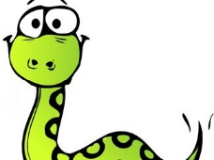
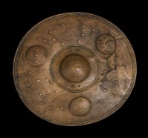
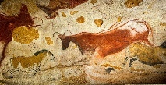
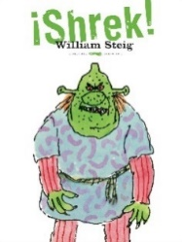
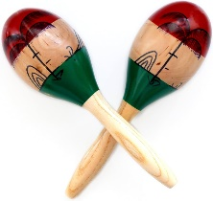
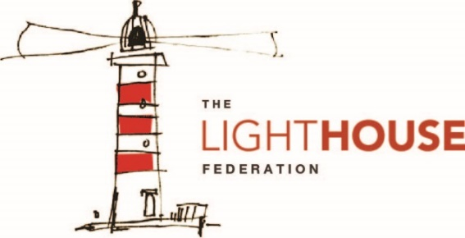
In Reading, your child will be…
- reading a range of fiction texts
- reading a range of non-fiction texts
following our Vipers structure.
In Writing, your child will be…
- writing a character description
- writing a conversation between two
characters
- writing a set of instructions.
In Mathematics, your child will be…
- subtracting numbers within 1,000
- multiplying and dividing using times tables facts
- measuring lengths to the nearest mm, cm and m.
In Modern Foreign Language (French), your child will be…
- learning how to name parts of the body, clothing and months of the year.
In Physical Education (PE), your child will be…
- practising a range of teamwork skills whilst playing archery & Gymnaastics.
In Religious Education (RE), your child will be…
- understanding why people make special journeys
- understanding what a pilgrimage is.
To enrich their curriculum experience, your child will be…
- visiting the local church to understand why Christmas is important to Christians.
In Music, your child will be…
- learning how to compose their own music
- practising keeping
a beat.
In Art and Design, your child will be…
- creating a Bronze Age shield
- using clay to create a beaker.
In Design Technology (DT), your child will be…
- making a 3D Neolithic wooden house
- evaluate their design and final product.
In Personal, Social, Health, Education (PSHE), your child will be…
- understanding differences between people and how to help when there are problems or conflicts between others.
In Computing, your child will be…
- learning how to use a spreadsheet
- improving the speed in which they can type.
In Science, your child will be…
- working scientifically to learn about rocks, fossils and soils. 
In Geography, your child will be…
- identifying physical and human features within the UK
- locating and comparing cities within the UK.
In History, your child will be…
- comparing the Stone Age, Bronze Age and Iron Age periods
- investigating Stone Age paintings, weaponry and clothing.

