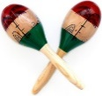
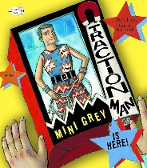
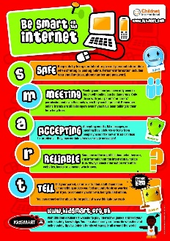
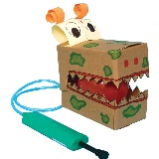
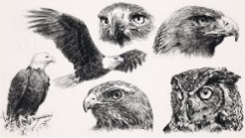
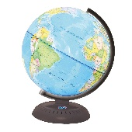
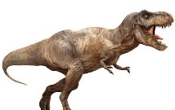
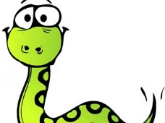
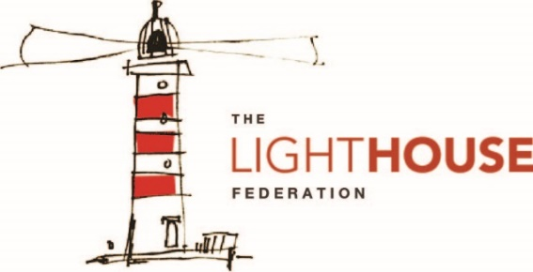
.
In Modern Foreign Language (French), your child will be…
- learning French greetings, numbers and family names.
In Physical Education (PE), your child will be…
- practising a range of basketball skills and learning to control the ball with both hands.
In Religious Education (RE), your child will be…
Learning about sacred places and why they are important to others.
To enrich their curriculum experience, your child will be…
- develop their knowledge and creativity through problem solving and the curiosity about predators.
In Music, your child will be…
- Learning about Harlem.
- Learning about Jazz, blues, gospel, hip-hop and R&B.

In Art and Design, your child will be…
- sketching birds of prey
- creating a colour wash
- exploring the work of
Jonathon Truss.
In Design Technology (DT), your child will be…
- understanding pneumatics
- designing, creating and evaluating a moving predator.
In Personal, Social, Health, Education (PSHE), your child will be…
- understanding what it means to be ‘me in my world’.
In Computing, your child will be…
- understanding how
to stay safe
online.
In Science, your child will be…
- learning about Health and Movement.
- understanding the
different food groups.
In Geography, your child will be…
- locating places in the Northern Hemisphere
- exploring biomes
- understanding what poaching is.
In History, your child will be…
- learning about pre-historic animals
- knowing how and why
animals become extinct.
In Mathematics, your child will be…
- understanding place value to 1,000
- adding to 1,000
- exploring unit and non-unit fractions
In Writing, your child will be…
- writing a character description
- writing a diary entry
- writing an informal letter based on Traction Man

In Reading, your child will be…
- reading a range of fiction texts
- reading a range of non-fiction texts
following our Vipers structure.

